1. Write the numbers in Spanish following the first example.
Example: fifty (50); 50 cincuenta
Fifty-one: ______________________________________________________________
Fifty -two ______________________________________________________________
Fifty-three ____________________________________________________________
Fifty-four ____________________________________________________________
Fifty-five ____________________________________________________________
Fifty-six ____________________________________________________________
Fifty-seven ____________________________________________________________
Fifty-eight ____________________________________________________________
Fifty-nine ____________________________________________________________
sixty ____________________________________________________________
forty ____________________________________________________________
forty-one ____________________________________________________________
forty-two ____________________________________________________________
forty-three ____________________________________________________________
forty-four____________________________________________________________
fourty-five____________________________________________________________
fourty-six__________________________________________________________
forty-seven ____________________________________________________________
forty-eight____________________________________________________________
forty-nine____________________________________________________________
fifty ____________________________________________________________
2. Addition (Suma) Write the equation in Spanish, including the solution.
Ejemplo: dos más cinco es igual a siete. (2 + 5 = 7). (Two plus five is equal to seven.
- 40 + 10 = 50 ______________________________________________________________________
- 40 + 7 = 47 ______________________________________________________________________
- 40 + 12 = 52 ______________________________________________________________________
- 40 + 13 = 53 ______________________________________________________________________
- g. 40 + 15 = 55 ______________________________________________________________________
- h. 40 + 16 = 56 _____________________________________________________________________
3. Subtraction (Resta): Write the equation in Spanish, including the solution.
Example: Resta (-) Subtraction equation: 1 - 1 = 0
Uno (1) menos (-) uno (1) = (igual a) cero
- 60 – 10 = 50 _________________________________________________________________
- 60 – 19 = 41 __________________________________________________________________
- 60 –18 = 42 __________________________________________________________________
- 60 – 17 = 43 ___________________________________________________________________
- 60 – 16 = 44 ___________________________________________________________________
- 60 – 15 = 45 ___________________________________________________________________
4. Multiplication (Multiplicación): Write the equation in Spanish, including the solution.
Example: Multiplicación (x) multiply the equation: 25 x 2 = 50
veinticinco (25) multiplicado por dos (x) dos (2) = (igual a) cincuenta (50)
- 24 x 2 = 48_________________________________________________________________
- 23 x 2 = 46 __________________________________________________________________
- 17 x 3 = 51 __________________________________________________________________
- 18 x 3 = 54 ___________________________________________________________________
- 19 x 3 = 57 ___________________________________________________________________
- 20 x 3 = 60 ___________________________________________________________________
4. Division (división): write the equation in Spanish, including the solution.
Example: división (÷) multiply the equation: 100 ÷ 2 = 50
Cien (100) dividido entre (÷) dos (2) = (igual a) cincuenta (50)
- 82 ÷ 2 = 41_________________________________________________________________
- 86 ÷ 2 = 43 __________________________________________________________________
- 88 ÷ 2 = 44 __________________________________________________________________
- 90 ÷ 2= 45 ___________________________________________________________________
- 94 ÷ 2= 48 ___________________________________________________________________
- 84 ÷ 2 = 47 ___________________________________________________________________
5. Fill the blank spaces with the number in parentheses in Spanish.
- Él compró (40) ______________________________ sillas de color gris.
- Ella compró (50) _____________________________ lápices de color negro.
- Ellos compraron (60) ___________________________ manzanas verdes.
- Nosotros compramos (70) ____________________________ boletos para ir al cine.
- Tú compraste (80) _________________________________ cajas de banana.
- Miguel compró (90) ________________________________ barras de jabón con fragancia de manzana.
- Martha compró (100) _______________________________ libros de cuento para la librería.
6. Pareo. (Match the letter and write in the provided space the correct Spanish number).
a. ________ 200 1. Trescientos
b. ________100 2. novecientos
c. ________ 500 3. Cuatrocientos
d. ________ 900 4. Cien
e. ________ 400 5. Quinientos
f. ___________300 6. Doscientos
g. ___________600 7. ochocientos
h. ___________700 8. Seiscientos
j. ___________800 9. Mil
k. ___________1000 10. Setecientos
7. Preguntas de dinero/monedas para contestar. (Money questions, answer to the best of your ability.)
Example: ¿Cuánto dinero tengo para comprar un borrador?
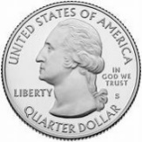
Veinticinco más (+) veinticinco más (+) veinticinco = igual a setenta y cinco centavos (75¢).
¿Cuántos centavos hay en un dólar?
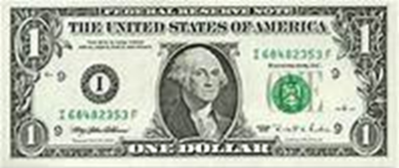
_____________________________________________________________________________________
¿Cuánto dinero tengo para comprar una manzana?
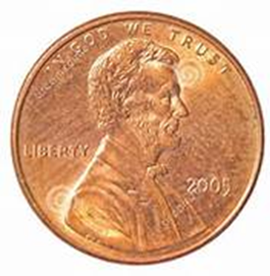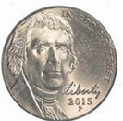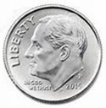
____________________________________________________________________________________
¿Cuánto dinero tengo para comprar una naranja en la marqueta?
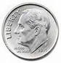
_____________________________________________________________________________________
¿Cuánto cuesta una pera en la tienda?
________________________________________________________________________________
¿Cuánto dinero tiene Juan para comprar un helado de fresa?
__________________________________________________________________________________
¿Cuánto tengo para comprar una piña en la marqueta?
___________________________________________________________________________________
¿Cuánto cuesta esta manzana? (Count the coins and write your answer in Spanish)
___________________________________________________________________________________
¿Cuánto cuesta el bolígrafo?
_____________________________________________________________________________________
¿Cuánto cuesta el lápiz,, de color azul?
__________________________________________________________________________________

